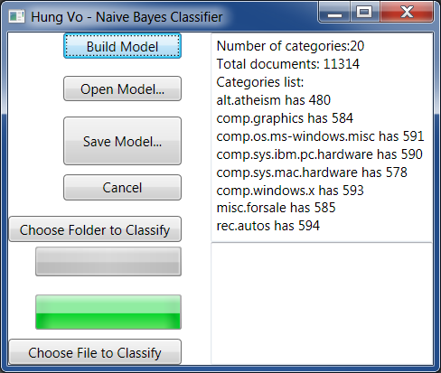
Requirements:
- MS Framework 3.5 (for run)
- MS Visual C# 2008 (for programming)

